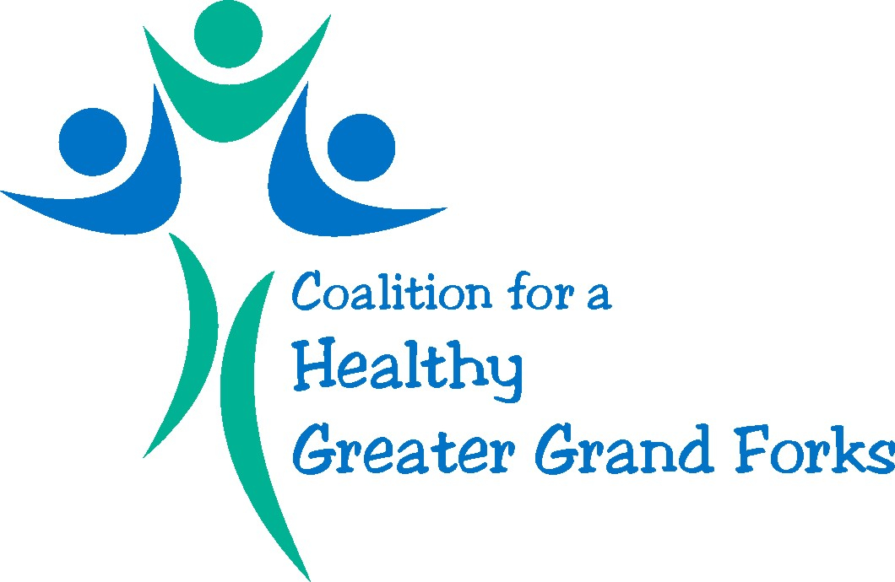

2018 Annual Meeting Agenda
March 15, 2018
2-3pm
Location: The Public Works Conference Room

Members present:

- Welcome & Introductions

- Sub-committee/initiative Updates

- Coalition Renaming – marketing ideas

- Mini Grant/Community Builders Update

- Member Sharing

Next meeting: April 19th at 2pm

