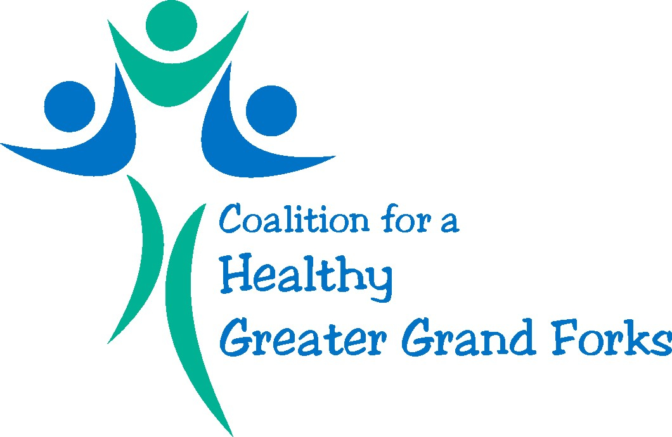

April 21st, 2016
2-3pm
Meeting Minutes

Present: Allen Anderson
Nicole Benson
Ashley Evenson
Kim Greendahl
Denae Grove
Carma Hanson
Earl Haugen
Audrey Lorenz
Leah Melquist
Kim Ruliffson
Todd Sabato
Haley Thorson
Jim Whitehead

Review of Minutes

- There were no questions and/or amendments to the minutes. Attendees were informed that the Coalition mission and vision statement were voted on and approved at the April 14th meeting of the Board of Directors.

Membership Update

- A description of both the membership requirement as well as membership policies have been clarified, allowing for a clearer estimate of the existence of a quorum. Some individuals who have yet to respond to Leah Melquist’s prior membership e-mail have been included in subsequent e-mails, under the auspices that they would continue to participate as an active member of the Coalition.

Community Assessment (see attached presentation)

- Audrey Lorenz provided an update on the progress of the Community Health Assessment, spearheaded by Altru with assistance from the University of North Dakota’s Masters of Public Health (MPH) program.

- Multi-modal data collection methods are being employed, including both community surveys and focus group interviews.

- Community survey was launched on April 12, and will remain open through May 15th. Both paper and electronic copies are available to residents of Grand Forks and Polk counties who are age 18 and older. Results of the quantitative portion of the assessment should be ready by the end of May. A press release has been provided to KNOX radio, as well as to local newspapers. All members are encouraged to complete the community survey, and forward it to members of the community.

- A series of focus groups have been scheduled which will specifically target both community leaders and special populations. A community forum is also hoping to be scheduled, with tentative plans for late June. Coalition-based priorities will be determined in July, after results of the community survey are reviewed in June.

Coalition Sub-Committees

- Leah Melquist presented information from the McDowell (NC) Health Coalition’s website, and facilitated discussion regarding possible subcommittees and working groups (http://www.mcdowellhealthcoalition.org/)

- Workgroup ideas included the following: obesity prevention/reduction, increasing physical activity/nutrition, tobacco use reduction and prevention, substance abuse prevention, safety, and social determinants of health

- Discussion ensued regarding social determinants of health, and whether it would be more advantageous to include as a separate working group or simply addressing such determinants as key elements within each working group

- Mental health was discussed as a key option for consideration. Likewise, the need for collaborative efforts within and between organizations and working groups was addressed.

