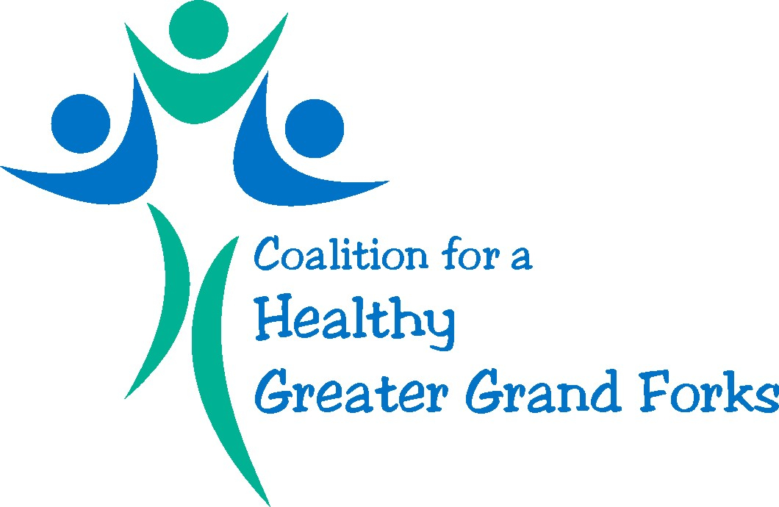

February 25th, 2016
Member Meeting Minutes

- Welcome & Introductions

Present: Allen Anderson (Grand Forks Public Health)
Kayla Bakewell (NDSU Extension Service)
Anne Bodensteiner (UND Health and Wellness Hub)
Bethany Brandvold (Polk County Public Health)
Abby Devine (UND Nursing)
Stephanie Erickson (City of Grand Forks Planning)
Kim Greendahl (Greenway)
Leah Melquist (Grand Forks Public Health)
Kim Ruliffson (UND Wellness Center)
Haley Thorson (Grand Forks Public Health)
Todd Sabato (UND Department of Kinesiology & Public Health Education)
Molly Soeby (NDSU Extension Service)
Peggy Jo Coll (CVIC)
Jim Whitehead (UND Department of Kinesiology & Public Health Education)
Nicole Benson (Altru)
Earl Haugen (MPO)

- Board updates

- SWOT analysis session was conducted in January, revealed that Coalition would benefit from taking a step back to re-evaluate goals and systemic objectives
- Board has met twice in last month – one of decisions from those sessions was temporary pause on providing funding to organizations for programming, so that we can assure that funds reflect updated mission and/or organizational goals
- Board met to discuss updated membership status and clarity (Section 2.1.1.) – sheet was distributed asking those present to complete where they see themselves fitting (Member v. Associate Member)
- Carma Hanson has submitted her notice of resignation. Audrey Lorenz has accepted an invitation to serve as Vice President.
- Meetings will continue during the summer to reflect the year-round efforts needed to promote health

- Discussion: Community Problems to Address

Discussion of community engagement took place, with specific issues to tackle

- Obesity
- Promoting Healthy Lifestyles
- Building Partnerships
- Health Advocacy
- Environmental Change
- Policy and Systems
- Meeting the Needs of a Changing Demographic
- Tobacco Prevention
- Elimination of Food Waste
- Safety Promotion
- Coordinating Health Efforts

“Through the support of healthy initiatives”

- Discussion: Mission Statement for Coalition

- Take a leading role in trying to make Greater Grand Forks a leading health and wellness community
- Fostering Collaboration
- Partnerships

Committed to being a leader in fostering collaborative partnerships that promote the environmental, policy-based, and behavioral health and wellness of the Greater Grand Forks area

Committed to being the leader to promote health and wellness in the Grand Forks community

- Discussion: Internal Coalition Goals – What tools or resources may be needed by the group to meet it?

- Presentations at Grand Forks and East Grand Forks city council meetings (possibility of going when we have an “ask” as opposed to simply providing information – maybe have a point person on the Board who can provide updates for us)
- Presentations at Board of Health (Quarterly)

- Discussion: Vision for the future-where do we see community in 5-10 years because of our efforts?

- Healthiest community
- GGF – a model community for health and wellness

- Round Table Discussion

- Earl Haugen reported that the online survey regarding the land use plan has received a boost due to Coalition e-mail efforts. There is still an opportunity to make comments throughout the process, with draft goals and objectives available online.. The next round will be in mid-April where synopsis will be given. A national expert will provide a 2.5 day training session on crafting a new bike pedestrian program.

