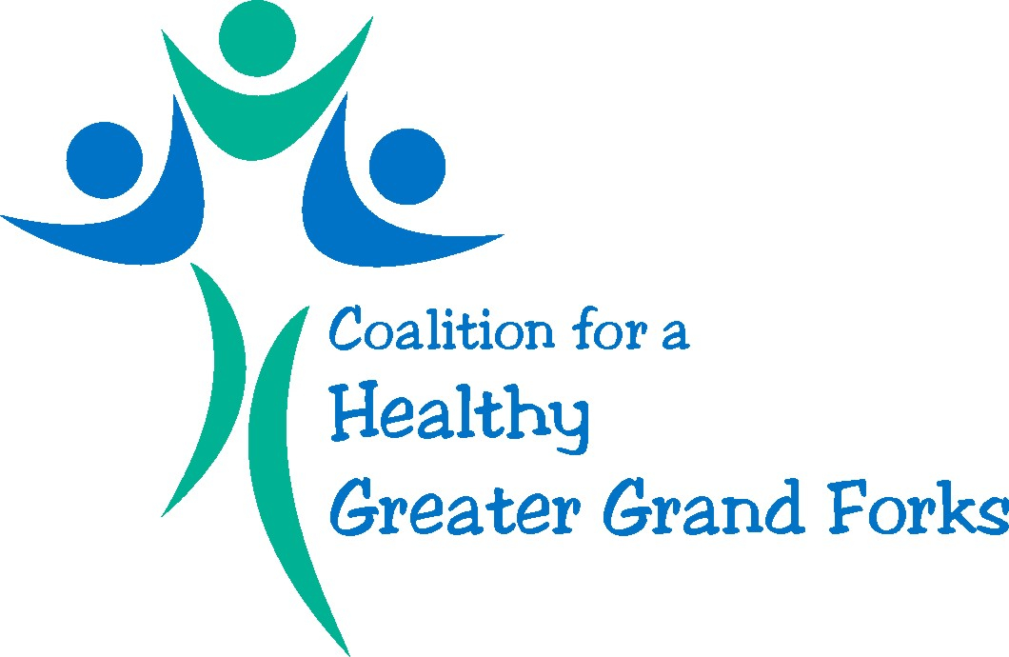

March 17th, 2016
2-3pm
Member Meeting Agenda

- Welcome & Introductions

- Review Minutes

- Coalition Membership

- Finalize Mission & Vision Statement

Mission
- We are committed to creating sustainable healthy environments through, fostering partnerships, advocating for health policy and improving health outcomes.

- The Coalition for a Healthy Greater Grand Forks leads a forum of organizations seeking to improve the health of individuals and families across the community

- The Coalition for a Healthy Greater Grand Forks embraces health by working on policy, system and environmental change for all through collaboration, communication and advocacy.
Vision
Our vision is for our community to be the healthiest possible place to live, work, and enjoy life.

- Next Steps

Next meeting: April 21st at 2pm

